**Intelligent Hydroponic System based Agriculture**

D.V. S Adwaith, P. Udath, G. Aditya Sai  
*Department of Electronics and Communication Engineering   
National Institute of Technology, Warangal*

***Abstract-*The rapidly increasing urbanization, population, and reduction in arable land are the main concerns prevailing in the agriculture sector which are should be addressed to maintain food supply to the population. A Hydroponic system is a viable alternative to fight the future food crisis. The principal advantage is that the plants in the hydroponic system consume less water than the conventionally grown plants. Other advantages include less competition for water and nutrition, climate independent, and significantly fewer pests. The proposed prototype in this paper is smart hydroponic system that is used to cultivate crops which is suggested by the machine learning model depending on the values of temperature, humidity, and pH level of the initial nutrient solution (before keeping plant in the water bed) as a input to the model.** **The prototype uses a ESP32 board and other required sensors to measure the parameters. The data measured by the sensors is displayed on the webserver.**

***Index Terms-*ESP32, camera module, ML algorithm, Accuracy of models, Data processing,Knime.**

I**.** INTRODUCTION

The rapidly increasing urbanization constantly possess a threat to available cultivable soil [1]. It was reported that the total arable area in 2013 was 18.6 million square miles which accounts for 37.73% of earth’s land. But in 1991 the area was 19.5million square miles [2]. Here comes the need of developing a system to grow plants without soil by providing the required nutrients and other suitable conditions to maximize the yield. Hydroponics, also known as nutriculture or tank farming, is the cultivation of crops in water that is supplied with all the required nutrients.[3] Temperature and humidity have a great effect on plant growth. A study shows that plants within the temperature range of 25°C to 30°C are prone to diseases from different pathogens [4]. It is reported that Foliar disease is more common among plants if the RH ranges from 80% to 100% [4]. Stomata plays a major role in gaseous exchange and transpiration. Transpiration process is affected by humidity. If humidity is more, very less water molecules enter into the atmosphere from plants to reach saturation.[5] Low humidity causes a high transpiration rate and the water content in plant decreases which cause plants to wilt and decrease the surface area for photosynthesis.[5] Temperatures largely affect the biochemical reactions taking place in plants. This is because the functions of enzymes taking part in these reactions are dependent on the temperature (and on pH). Up to a certain temperature (35°C-40 °C) the rate of these reactions increases with temperature and then the increase in temperature negatively affects the growth of the plants. Closing of stomata takes place in order to prevent water loss in high-temperature conditions which affects photosynthesis.[6] The availability of nutrients in the soil is affected by the pH of the soil. A suitable pH range of the developing medium will give a better yield by supplying essential nutrients to the plants. Based on the above requirements, a prototype is designed in which with the help of a smart hydroponic system different condition sets of parameters are tested on plant/crop, and suitable values of parameters are provided

II. LITERATURE SURVEY

During the literature survey, we came across a few smart hydroponic systems designed to grow plants in integration with IOT-based technologies to increase flexibility. A hydroponic monitoring system [8] is designed using ESP8266 micro controller as a Wi-Fi module that sends the temperature and humidity values to the internet. It also sends data to the cloud using MQTT broker. Users can subscribe and view the conditions of the plant from the cloud. No control modules were implemented which is a major drawback. A novel hydroponics system [9] designed using Raspberry Pi-3 board designed with 10-bit ADC will analyze the data and and display message display necessary messages, control motor operation activating alarm, and publish important data on the dashboard. The computing capacity of Raspberry Pi-3 is not used which is a major cost wastage. A GSM based hydroponics monitoring system [10] was implemented using ATmega328P micro controller, DHT11 Sensor, pH sensor, Water level sensor. The data captured by sensor is transferred to the user end using cellular communication protocol employing GSM module.

A reliable hydroponics monitoring system [11] is designed using Arduino Mega 2560, wireless sensor networks (WSNs), Node MCU, actuators and camera. The temperature and relative humidity of air are measured using the SHT15 sensor. This system displays the real time data and also enables to access the data using Wi-Fi communication protocol. A machine learning model [12] is proposed to predict the nutrition value in each plant based on the input conditions entered by the user. A Raspberry Pi board, Water temperature sensor, EC sensor, DHT11 Sensor, pH sensor, Arduino UNO were used to achieve the desired system. It is a much efficient system which not only monitors the plant but also predicts the yield based on the conditions provided. An IOT-Based Hydroponic System [13]is designed using Blynk Platform. The pH and TDS sensors used in this prototype are accurately calibrated using BNC probe. Greek basil seed were used as the subject. Three samples of same plant are subjected to different conditions. Smart Hydroponic farming system [14] is one such prototype which was designed to encourage farmers to do vertical planting. The water parameters are constantly monitored and the water pump or solenoid pump is turned on when they fall below a threshold value. A prototype using cyber physical social system [15] is designed which measures different parameters in hydroponic system such as temperature, light intensity, humidity, pH, EC. The prototype is integrated with Telegram messenger to make the hydroponic system more flexible. The major limitation is that this prototype requires internet connection to monitor plants. IOT based Hydroponic Farm [16] is designed using “Non circulatory method”-providing the supplements when needed only. Plants are kept in the developing medium in the pots and are put such that bring down 2-3cm of pots is submerged in the supplement tank. Requires low tech and little upkeep. Limitations of manual hydroponics is resolved. A Hydroponic Monitoring System [17] is designed using an ESP8266 micro controller as a Wi-Fi module that sends the values of humidity and temperature to the internet. They also used the information from the sensors like the pH sensor to control the electrical conductivity and Ph of their system. Here, the Front-End application is used to act as a mediator between the system and the user. Smart Hydroponic Farming [18] is designed using ESP8266 as a Wi-Fi module, DHT11 sensor, Soil Moisture Sensor (KG003), Ultrasonic Sensor (HC-SR04), and Greenhouse architecture used. This module sends the values of sensors to the internet. Here, the Blynk prototyping platform is used over the internet. Here, the advantage is the Smart Control Greenhouse which enhances the use of electricity and water.

III.PROTYPE AND IMPLEMENTATION

A cost effective, low power, real time motoring prototype is designed which uses ESP32 developing board. The work flow of system is shown in Fig-1.First,The value of pH of the nutrient solution and temperature, humidity of atmosphere near the system (before keeping the plant) are fed as input to ML model which uses __________ algorithm. During this experiment, the model is loaded with the dataset collected from the Kaggle platform. We use ___________algorithm to predict the crop that would give a satisfactory yield if grown in the hydroponic system. The user then plants the crop which was suggested by ML model in the hydroponic system. The values of parameters are also loaded into the ESP32 controller, hence the system always tries to maintain those conditions. When the plant starts growing in the system ,they consume the nutrients and may change the surrounding temperature and humidity. But the Esp32 ,along with the help of pumps and fan, will try to maintain the constant conditions. The flowchart of the system is show in Fig-2.The water pump, ph buffer pump, fan and nutrient pump are turned ON whenever the values of those parameters drop below the threshold values. Complete block diagram of the system is given in Fig-3.

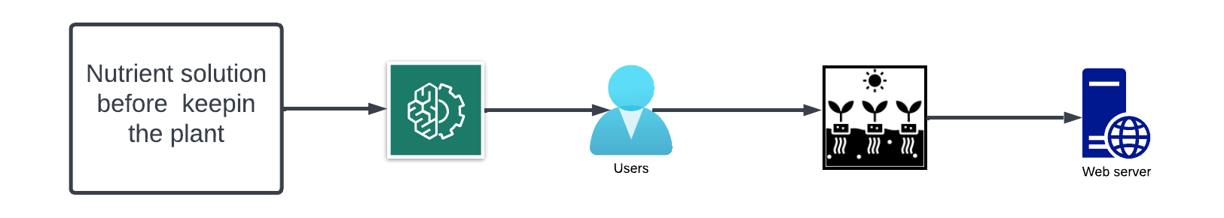

Fig-1.WorkFlow of the system.

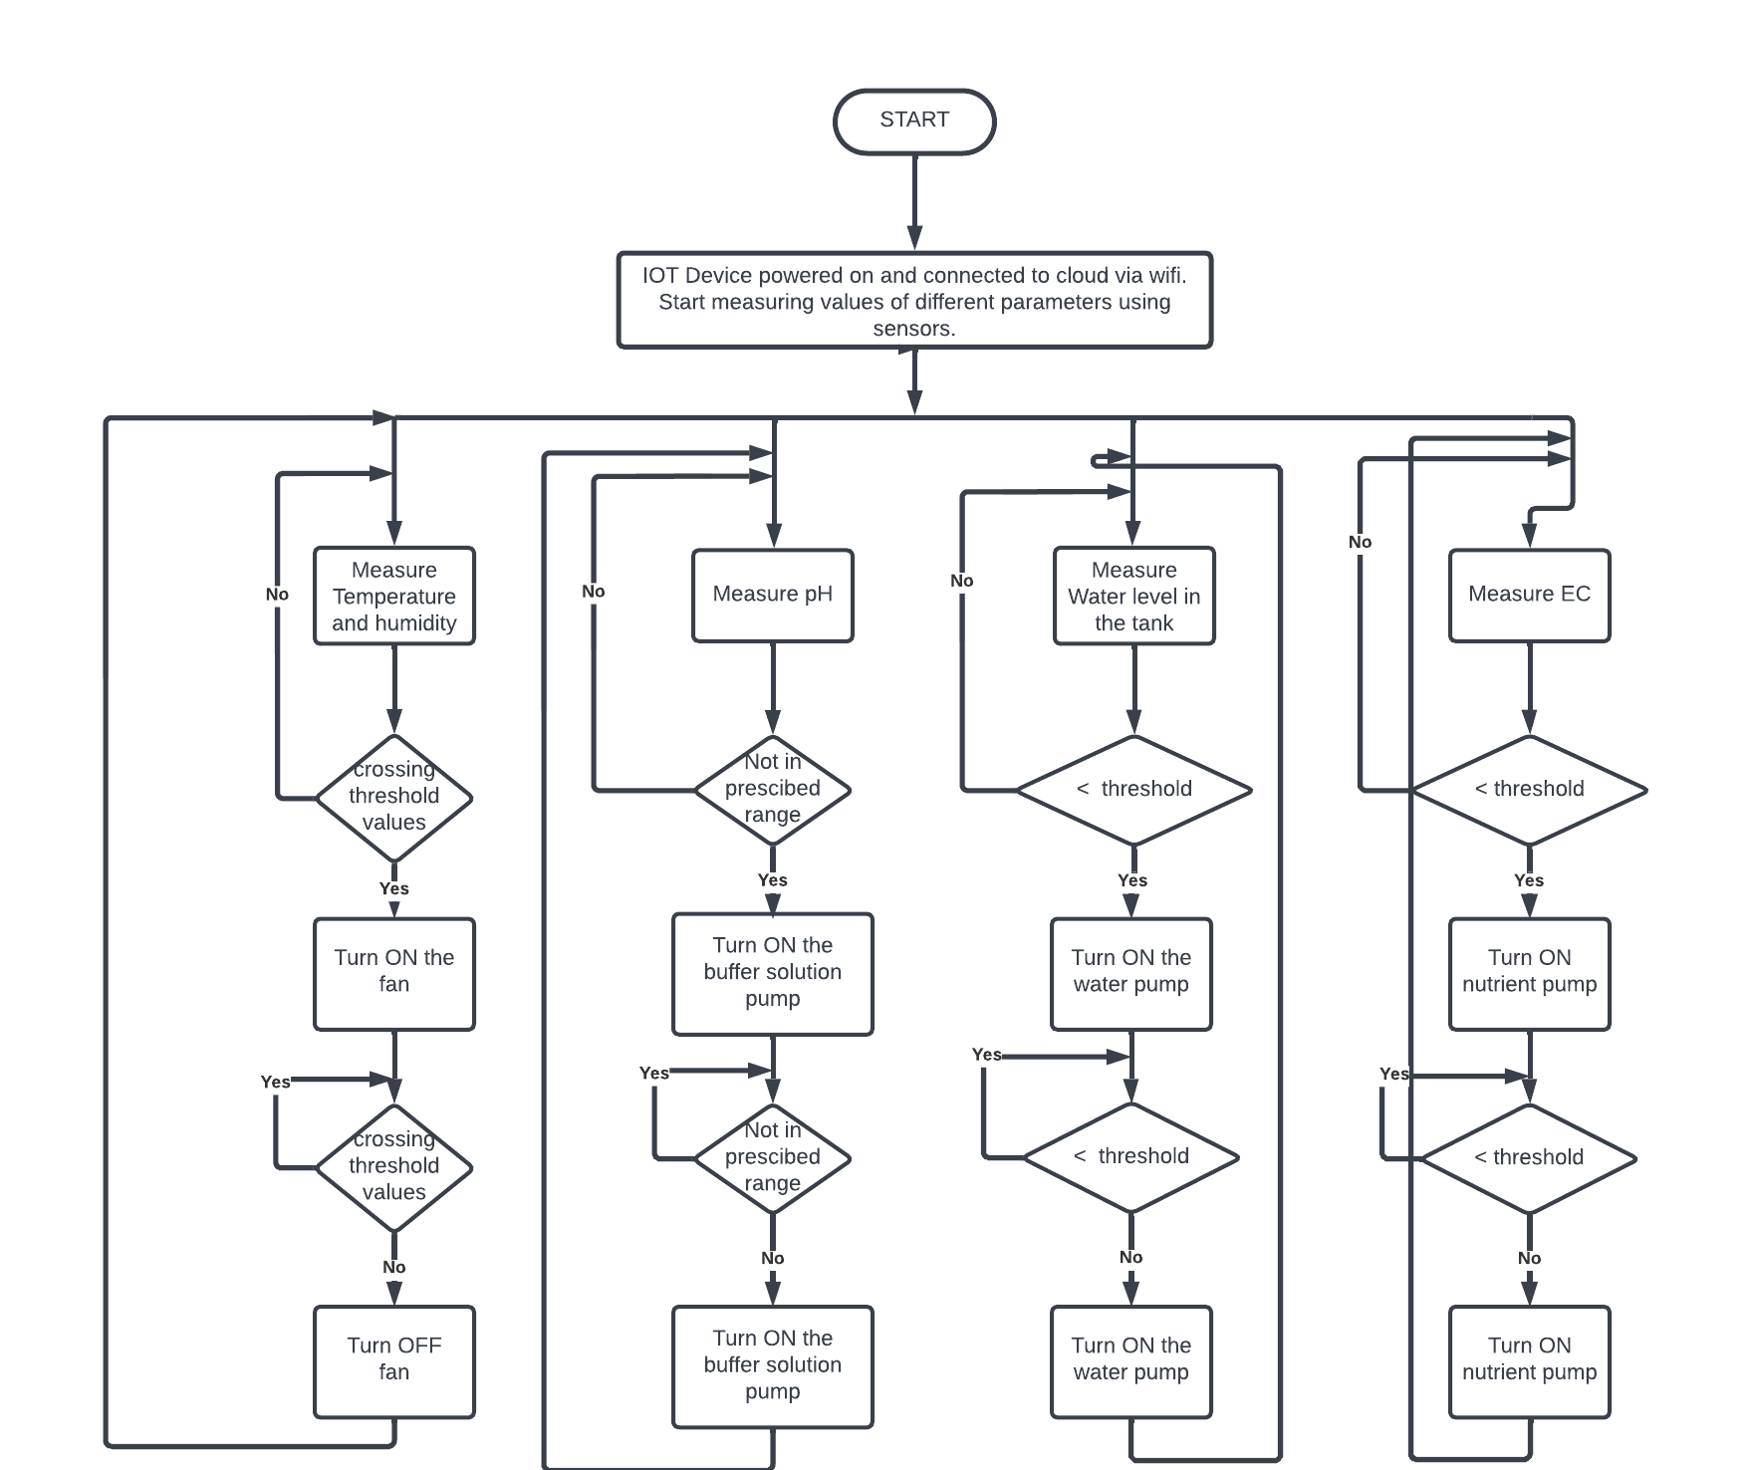  
  
Fig-2.Flowchart of the system

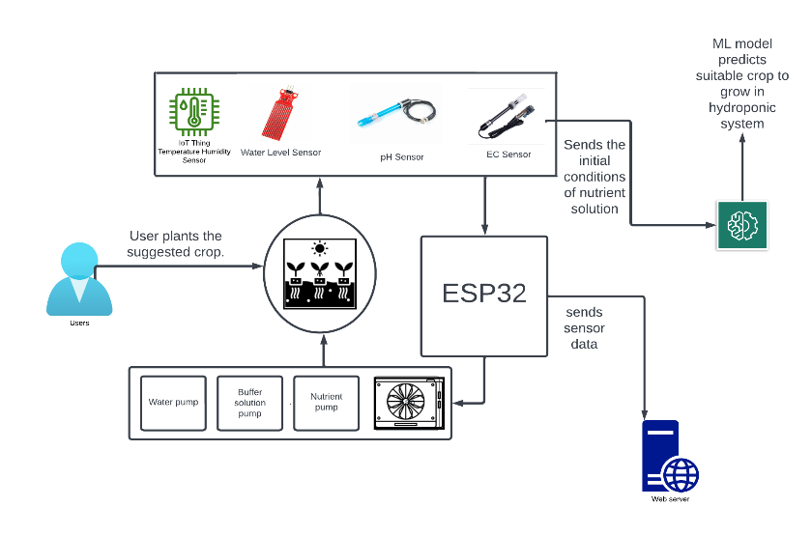Fig-3.Blockdiagram of the prototype.

A.ESP32  
The ESP32 is a small-size, low-power consumption module. It is designed for smart IoT applications with the TSMC low-power 40nm technology. It is a single 2.4GHz Wi-Fi and Bluetooth Combo chip. ESP32 contains an antenna switch, filters, low-noise receive amplifier, RF balun, power amplifier, and power management modules. The ESP32 is not expensive and specialized Wi-Fi testing equipment.

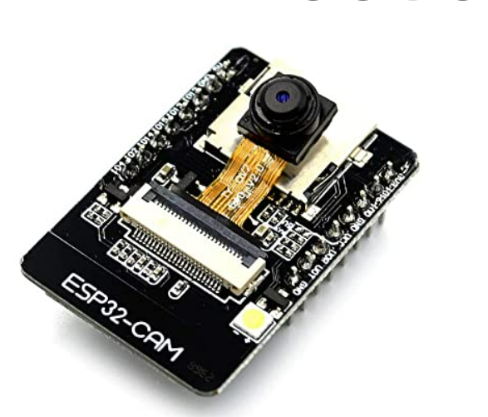 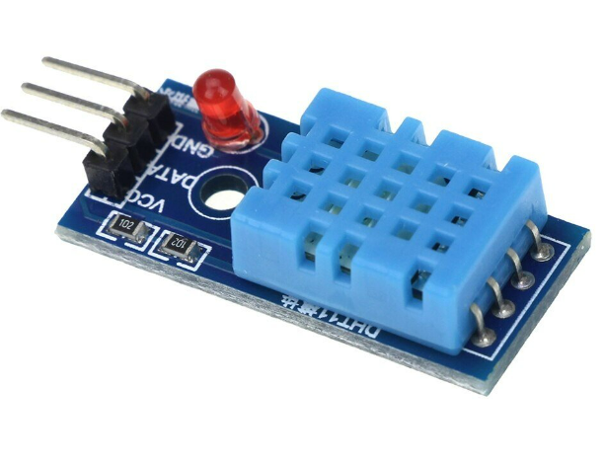   
 Fig-4.ESP32 Fig-5.DHT11

B.DHT11  
The DHT11(Digital Temperature and Humidity) Sensor is a basic, and low-cost sensor. It measures the surrounding air using a thermistor and a capacitive humidity sensor and sends the digital signal to the data pin. The sensor will get new data from it once every 2 seconds so the result that we get now is 2 seconds late. It is Good for 20-80% humidity readings with 5% accuracy and 0-50°C temperature readings with ±2°C accuracy.

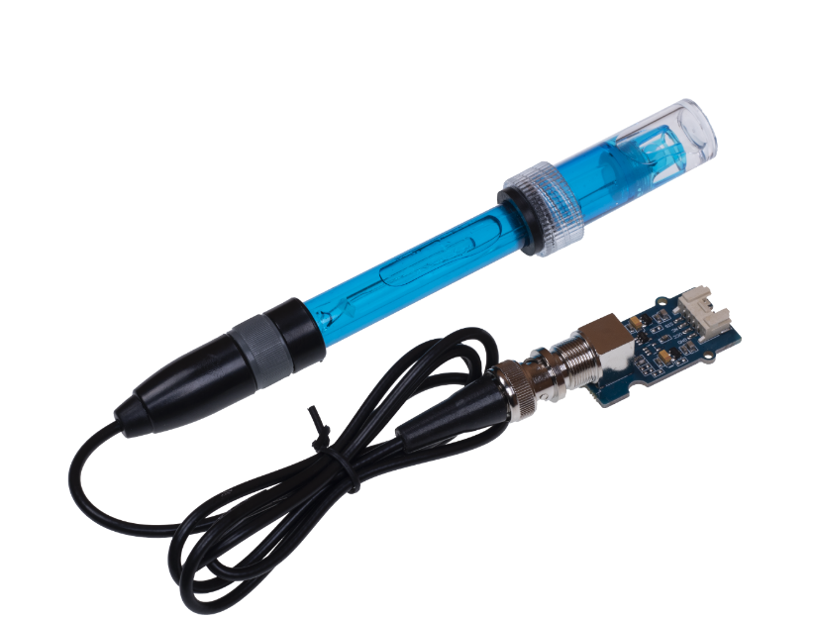 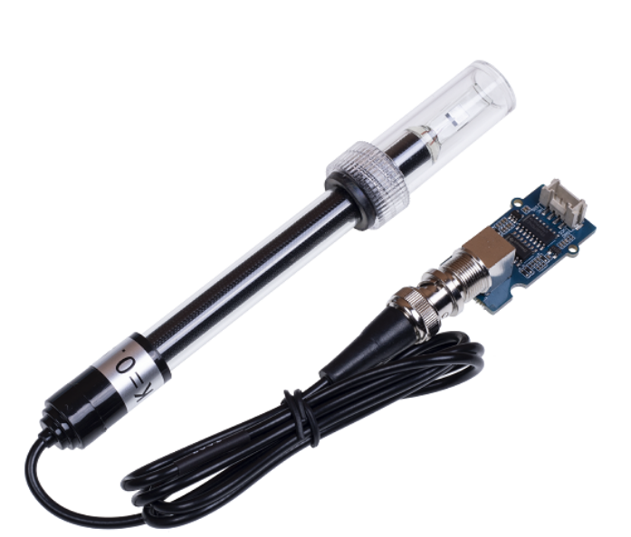  
 Fig-6.pH sensor Fig-7.EC Sensor

C.pH:  
A pH sensor is designed to measure the alkalinity or acidity of the water with a value between 0-14. When the pH value is 7 It is considered neutral, above 7 is alkaline and below 7 is acidic. It operates over the temperature range of 0° to 80°C. Most pH sensors are designed with -59.16 mV / pH sensitivity at 25°C. pH sensors are widely used in many industries such as chemicals, and pharmaceuticals.

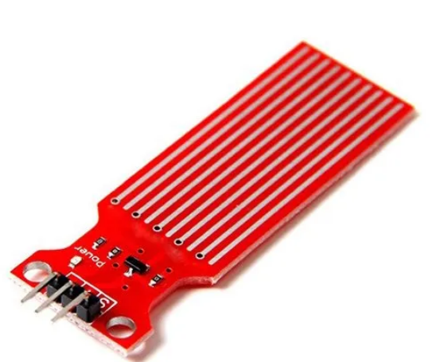 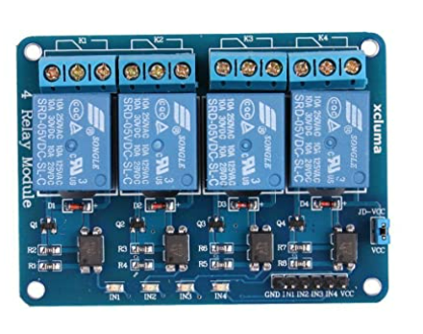

Fig-8.Water level Sensor Fig-9.four channel relay

D.EC  
An EC (Electrical Conductivity) sensor is designed to monitor the strength of the nutrient solution. For hydroponic nutrient solutions, the EC values can range from 500 to 2000 **µS/cm**, or 0.5 to 2 mS/cm. If the strength is too strong, we can add water, else we can add fertilizer. The BNC Probe Interface makes the sensor easy to use. It has a Compact size for easy development and is cost-effective.

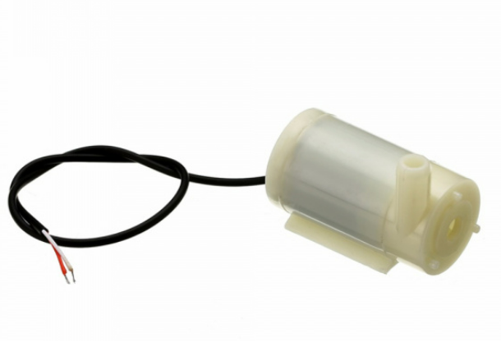 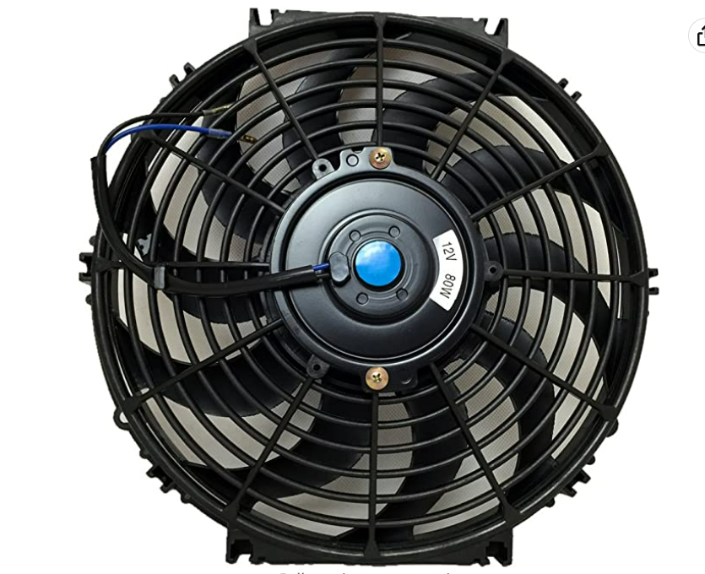

Fig-10.Pump Fig-11.Fan

E.Water-levelsensor  
The water-level sensor is specifically designed to indicate the depth of water by calculating the pressure at that depth. It works by using sensor probes. These probes send information back to the Wi-Fi module. Then It can be automatically programmed to turn on the pump to refill the water again.

F.4-channel-relay  
The four-channel relay board is used to control the loads such as solenoid valves and pumps. It is designed to interact with the microcontrollers like ESP32, Arduino, or Raspberry Pi. The contacts on each relay are specific for 250VAC and 30VDC and 10A in each case. It has a supply voltage of 3.75-6V.

The major advatange of this workflow over the conventional one is that we are enabling the user to completely utilize the advatnages of hydroponics.

IV.MACHINE LEARNING

This sections of work has the following steps –

A.Data collection-data is collected from kaggle platform.the csv file is downloaded and dumped into the KNIME platform.

B.Data processing-Required features are selected from the table.The dataset collected here contains N, P, K, pH, temperature, humidity as features out of which we use temperature,pH and humidity.

C.Applying the ML algorithm-

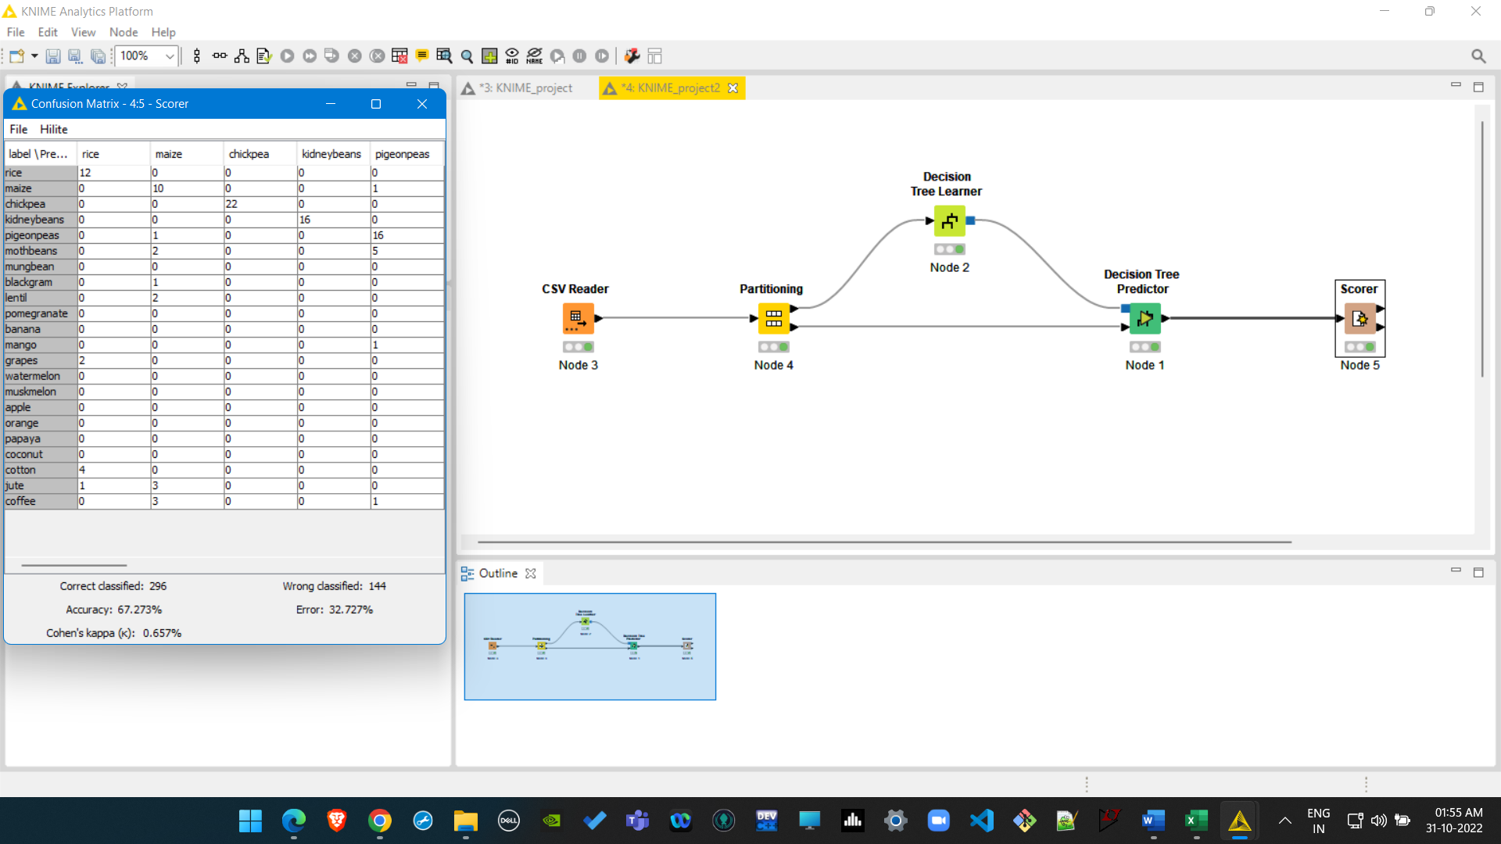  
Decision tree  
  
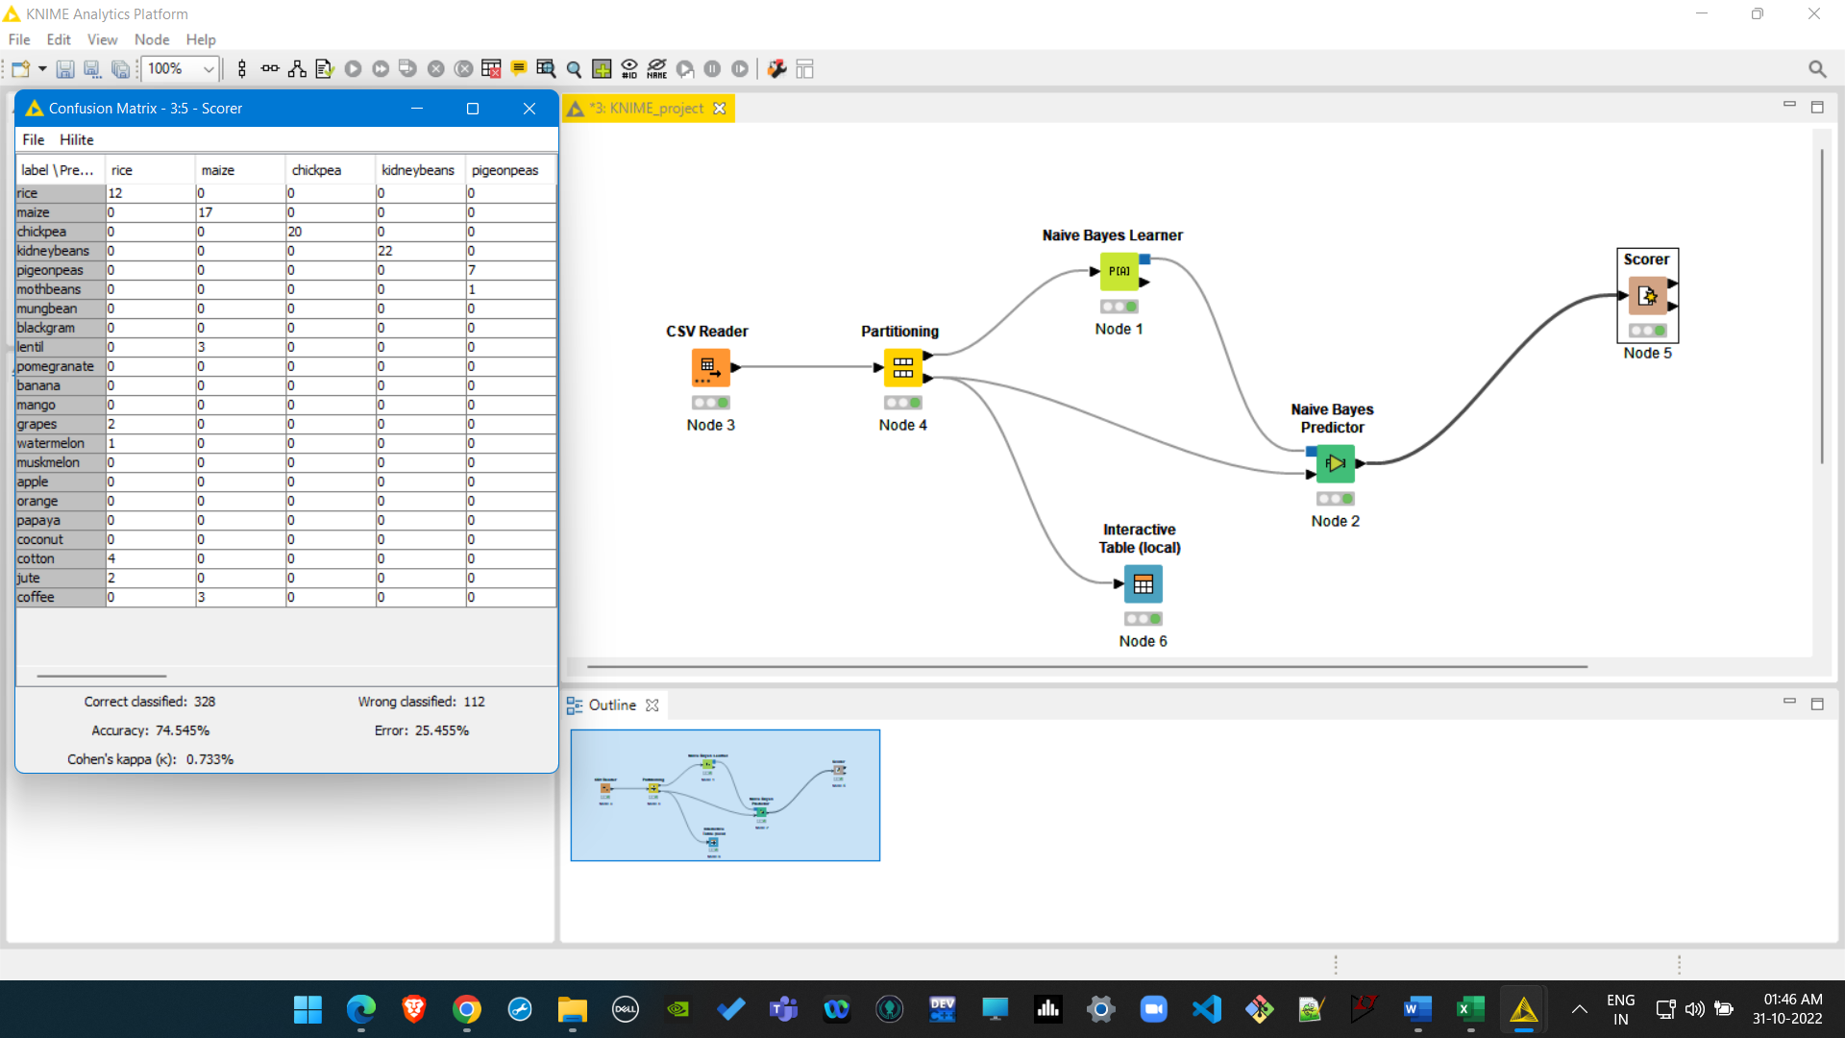  
Naive Bayes   
  
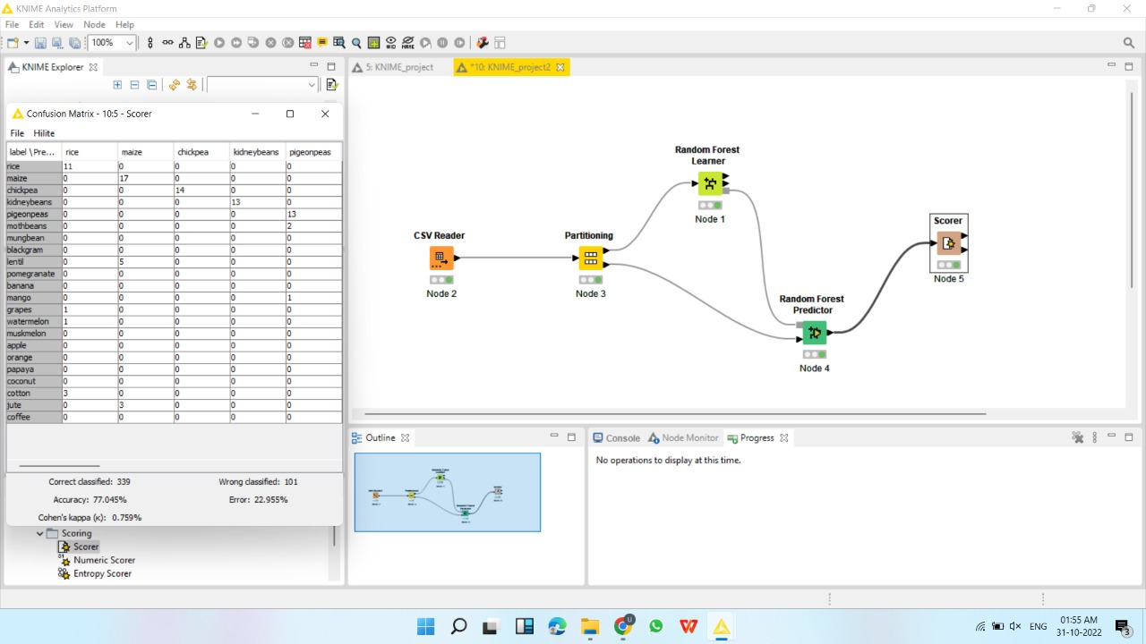  
Random Forest

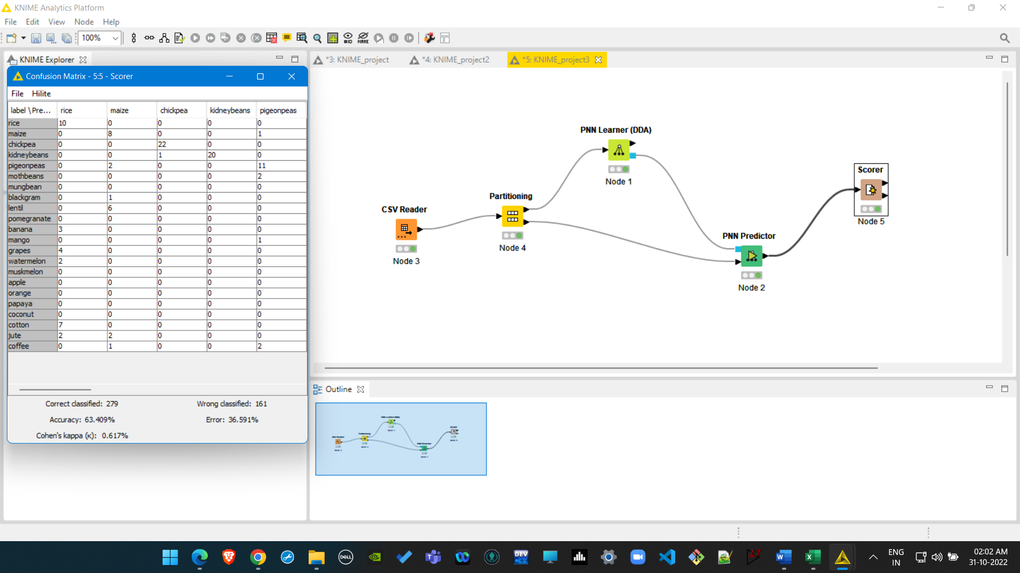  
Probabilistic Neural network  
  
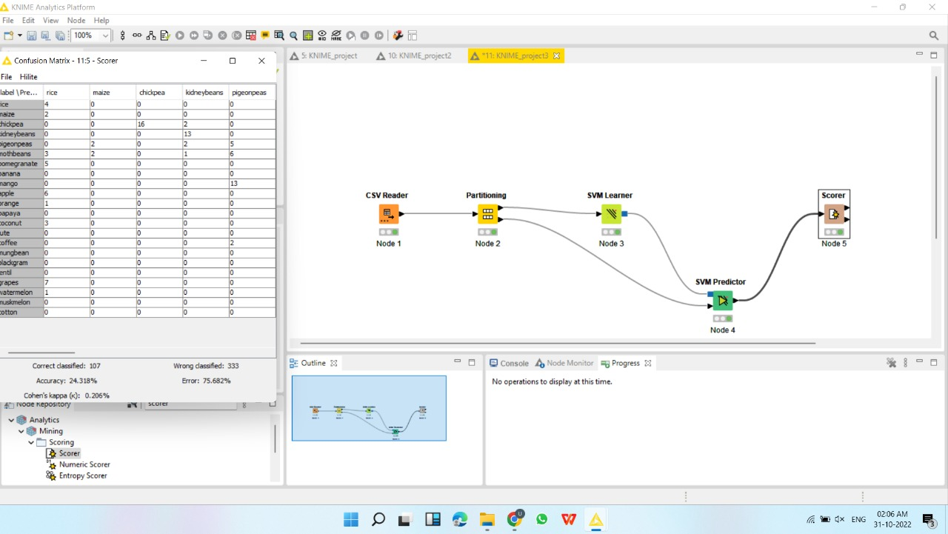  
Support Vector Machine

**REFERENCES**

[1]M. Ayaz, M. Ammad-Uddin, Z. Sharif, A. Mansour and E. -H. M. Aggoune, "Internet-of-Things (IoT)-Based Smart Agriculture: Toward Making the Fields Talk," in IEEE Access, vol. 7, pp. 129551-129583, 2019, doi: 10.1109/ACCESS.2019.2932609.

[2] L. Zhang, I. K. Dabipi and W. L. Brown, "Internet of Things applications for agriculture" in Internet of Things A to Z: Technologies and Applications, 2018.

[3] Britannica, T. Editors of Encyclopaedia (2022, October 8). hydroponics. Encyclopedia Britannica. <https://www.britannica.com/topic/hydroponics>

[4] R. Achary, R. R, R. K and P. V, "Effect of Temperature and Relative Humidity on Onion farms and its Monitoring by using IoT Based Smart Farming System," 2022 International Conference on Communication, Computing and Internet of Things (IC3IoT), 2022, pp. 1-6, doi: 10.1109/IC3IOT53935.2022.9767884.

[5] Dr.Amit Bhatnagar, senior search officer, department of agronomy, G.B. PANT UNIVERSITY OF AGRICULTURE AND TECHNOLOGY :<https://www.youtube.com/watch?v=Xg64TsUAFNE>

[6] Dr.Amit Bhatnagar, senior search officer, department of agronomy, G.B. PANT UNIVERSITY OF AGRICULTURE AND TECHNOLOGY :<https://www.youtube.com/watch?v=Pw30JhkVP5g>

[7]<https://www.insightsonindia.com/indian-geography-2/soils/problems-of-soil/>

[8]N. K. Bharti, M. D. Dongargaonkar, I. B. Kudkar, S. Das and M. Kenia, "Hydroponics System for Soilless Farming Integrated with Android Application by Internet of Things and MQTT Broker," *2019 IEEE Pune Section International Conference (PuneCon)*, 2019, pp. 1-5, doi: 10.1109/PuneCon46936.2019.9105847

[9]C. Joshitha, P. Kanakaraja, K. S. Kumar, P. Akanksha and G. Satish, "An eye on hydroponics: The IoT initiative," 2021 7th International Conference on Electrical Energy Systems (ICEES), 2021, pp. 553-557, doi: 10.1109/ICEES51510.2021.9383694.

[10]M. F. Ali, P. Thakur, P. Mendiratta and N. Gupta, "IoT-based Solar Hydroponics Farming," *2019 6th International Conference on Computing for Sustainable Global Development (INDIACom)*, 2019, pp. 927-931.

[11]T. Namgyel *et al*., "IoT based hydroponic system with supplementary LED light for smart home farming of lettuce," *2018 15th International Conference on Electrical Engineering/Electronics, Computer, Telecommunications and Information Technology (ECTI-CON)*, 2018, pp. 221-224, doi: 10.1109/ECTICon.2018.8619983.

[12]H. K. Srinidhi, H. S. Shreenidhi and G. S. Vishnu, "Smart Hydroponics system integrating with IoT and Machine learning algorithm," *2020 International Conference on Recent Trends on Electronics, Information, Communication & Technology (RTEICT)*, 2020, pp. 261-264, doi: 10.1109/RTEICT49044.2020.9315549.

[13]R. S. Al-Gharibi, "IoT-Based Hydroponic System," 2021 International Conference on System, Computation, Automation and Networking (ICSCAN), 2021, pp. 1-6, doi: 10.1109/ICSCAN53069.2021.9526391.

[14] S. Ruengittinun, S. Phongsamsuan and P. Sureeratanakorn, "Applied internet of thing for smart hydroponic farming ecosystem (HFE)," 2017 10th International Conference on Ubi-media Computing and Workshops (Ubi-Media), 2017, pp. 1-4, doi: 10.1109/UMEDIA.2017.8074148.

[15] R. E. N. Sisyanto, Suhardi and N. B. Kurniawan, "Hydroponic smart farming using cyber physical social system with telegram messenger," 2017 International Conference on Information Technology Systems and Innovation (ICITSI), 2017, pp. 239-245, doi: 10.1109/ICITSI.2017.8267950.

[16] N. Bakhtar, V. Chhabria, I. Chougle, H. Vidhrani and R. Hande, "IoT based Hydroponic Farm," 2018 International Conference on Smart Systems and Inventive Technology (ICSSIT), 2018, pp. 205-209, doi: 10.1109/ICSSIT.2018.8748447.

[17]A. Munandar et al., "Design and development of an IoT-based smart hydroponic system," 2018 International Seminar on Research of Information Technology and Intelligent Systems (ISRITI), 2018, pp. 582-586, doi: 10.1109/ISRITI.2018.8864340.

[18]J. Pitakphongmetha, N. Boonnam, S. Wongkoon, T. Horanont, D. Somkiadcharoen and J. Prapakornpilai, "Internet of things for planting in smart farm hydroponics style," 2016 International Computer Science and Engineering Conference (ICSEC), 2016, pp. 1-5, doi: 10.1109/ICSEC.2016.7859872.